Original Article

Advance use of AI and Machine Learning for search recommendation in E commerce applications

Authors name

University name

Dates

Abstract: In today’s busy world, almost all people around the people are preferring ecommerce businesses. Therefore. In the digital era, ecommerce is considered an integral part of customer’s lives because it is offering a vast array of products and services. For enhancing the user experience and increase conversation rate, various e-commerce platforms are used and they are relying on advanced technologies like Artificial Intelligence, and Machine Learning for search recommendation systems. This paper will provide a comprehensive overview of the significant role of AI and ML play for optimizing search recommendations in e-commerce application. Secondly, there is also some information regarding various technologies used for enhancing e-commerce business. lastly, the article will be concluded by focusing on the immense potential of ML and AI for transforming the landscape of e-commerce.

Keywords: E-commerce, Digital Era, Artificial Intelligence, Machine Learning, Advanced technologies.

1. **Introduction**

With the introduction of E-commerce, the focus of people shopping has been changed. The reason is that it is offering convenience, accessibility, and variety like never before. However, the main challenge in the field is related to ever-expanding product catalog and enhancing consumer expectations and consumer finds difficulty in finding the right product quickly. For addressing this challenge, the e-commerce platforms are harnessing the power of Machine Learning and Artificial Intelligence and Machine Learning for personalizing search recommendations. Therefore, it will ultimately enhance the user experience and sales will be increased too [1].

1. **Literature review**

This section will show how the previous researcher had showed important findings on the related topic.

**ML and AI in ecommerce**

Both of these advanced technologies are at the forefront of transforming the e-commerce in positive direction. According to this, the AI algorithms are analyzing the vast amounts of data. This data includes user behavior, product information, purchase data, and historical data. Due to this, it is possible for the system to provide personalized recommendations. Furthermore, the machine learning models are continuously adapting and learning to user preferences. Due to this, it will become simple to make search recommendations highly accurate and relevant to the system [2].

**Search Recommendation Techniques**

According to this, the author had discussed about some important techniques employed in ecommerce search recommendation systems. From them, the first one is collaborative filtering. This technique is analyzing the user behavior and preferences to recommend products according to the behavior of similar users. The next technique is Content-based Filtering. This technique is recommending products according to their attributes and user profiles. Therefore, it will match the user preferences with product features. The third technique is hybrid model. This technique had combined the content-based filtering and collaborative methods and offers a more robust recommendation system. it can be applied by leveraging the strengths of both approaches [3]. The last technique is Deep learning. There are some deep learning networks are employed for capturing complex relationships, patterns in present in user data that will result in more accurate recommendations [3].

**Some challenges in AI-Driven Search Recommendations**

Beside some important benefits provided by AI and ML, there are some important challenges presented by an author are given below [4].

The first challenge is related to data privacy and security. It was not simple to handle sensitive data. Therefore, the user data requires robust security measure for protecting user privacy. The second challenge is related to scalability because when the ecommerce platform grows then, scalability of AI models become extremely tough. The third challenge is about Bias and Fairness because ensuring recommendations are not properly fair and free from bias and it is extremely important to avoid discrimination. Moreover, it was not simple to evaluate metrices for determining the effectiveness of recommending products [4].

**Some Advantages of AI and ML in ecommerce**

As the use of AI and ML is necessary because of many advantages. One author had provided some valuable information it.

All recommendations are tailored to individual user preference and it will increase the likelihood of conversion. Secondly, by using these advance technologies, there will be huge increment in the sales and it will lead towards higher sales and revenue. The last advantage is related to reduced cart abandonment. With some relevant recommendations by using AI will minimize cart abandonment rates [5].

1. **Data architecture platform on Cloud**

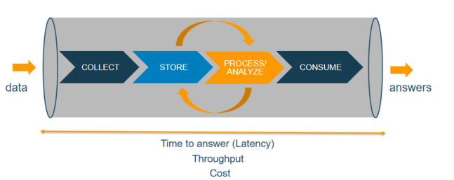

Figure 1: Data processing Pipeline for ecommerce

From the given figure above, it shows that the entire architecture of the data analysis is consisted of four main stages. These four stages include collecting, storing, processing and consuming the data. Furthermore, each stage contains a different cloud service specially for handling various tasks regarding ecommerce. All these services work together to streamlining the entire process [6].

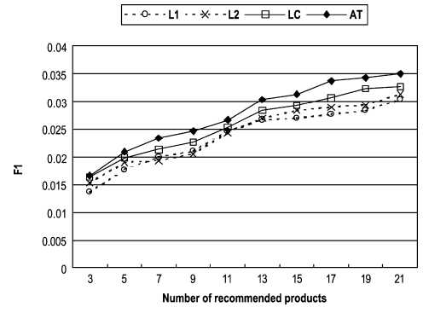

Figure 2: Graph about the impact of Grain Specification

When AI algorithm is applied on the ecommerce businesses, then there is a need to evaluate the impact of grain specifications on the search recommendation quality. Therefore, an experiment will be performed with four types of grain. These types include grain at level 1, grain at level 2, level-crossing grain, and grain on adjusted taxonomy that are given in the figure 2. Therefore, LC will be specified by ta chief marketing manager of C web retailer. Furthermore, for specifying AT, there is a need to select 10 level 2 grain so it will minimize the threshold level varies from 20 to 65 [2].

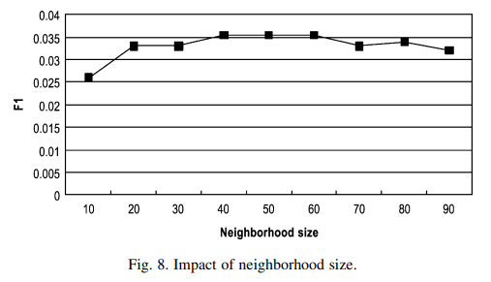

Figure 3: The impact of Neighboring size on the data

The above graph is showing the information about the neighboring size of the ecommerce system. it shows that the size of the neighborhood contains a huge impact on the search recommendation quality of the ecommerce products. Therefore, for determining the sensitivity level of the ecommerce neighborhood size, there is a need to perform an experiment where the numbers of neighbors will be varied and also computed with F1 metric. Furthermore, the experimental results are shown in the graph above. The results are showing that the size of neighborhood is not affecting the top-N search recommendations [3]. However, the value of recommendation quality will be increased as the number of neighbors increased. when the certain point is reached, then such improvement gains diminish and the quality become worse. Also, when a lot of neighbors are chosen, then it will result in a lot of noise for those who have high correlates. From the above experiment results, the maximum peak reached at the area between 40 and 60. For this, there is a need to use 50 is the ideal choice of neighborhood size. With this neighboring size, the search size will be improved and better results will be obtained. [4]

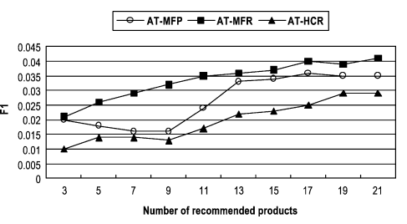

Figure 4: The recommendation generation method's impact on the system

The above graph is showing the information regarding the impact of the generation method in detail. It is applied for comparing the relative performance of MEP, MFR, and HCR method in the search recommendation generation. Therefore, an experiment will be performed where all of these parameters will be set accurately to obtain required results to a fixed value [7]. Furthermore, also these methods will be applied on the dataset. However, the required results can be viewed from the relative performance differences among these methods are extremely large. The reason behind it is that the working of MFR is quite better compared with other two methods [8]. The results are showing main evidence that the usage of web log data will increase the quality of search recommendation compared with purchases data only. Therefore, MFR recommendation generation method will be ideal to use for the remaining experiments [6].

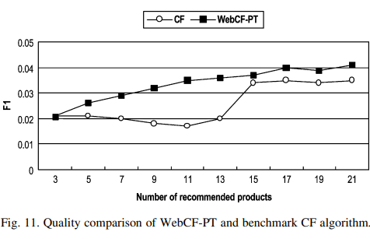

Figure 5: A graph about the Quality comparison of Web CF_PT and Benchmark CF algorithm

The above graph is providing valuable information about the quality comparison with the benchmark CF algorithm. When all optimal values of the parameters are obtained, then compare the recommendation quality of WebCF-PT is important with the benchmark CF algorithm. After comparing the results, it can be observed that the working of WebCF-PT is extremely better compared with the benchmark CF algorithm at all the numbers of recommended products. Another point is that WebCF-PT is using the optimal choice for each of the required parameter. It means that better result will be obtained by doing this with average improvement of 32% [4].

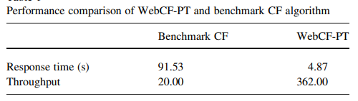

Figure 6: A Table about the performance comparison between the CF algorithm and WebCF-PT

The above table is showing the performance comparison between the benchmark CF algorithm and WebCF-PT. it shows that the response time of WebCF-PT is too much lower compared with the other. Also, the throughput value is extremely high that shows its reliability with the system in search recommendations [4].

1. Conclusion

Summing up all the discussion from above, it is concluded that the use of AI and ML in search recommendation system had revolutionized the ecommerce industry. The reason behind it is that it provides personized and relevant product suggestions to users. However, these technologies also contain various challenges that are linked wit data privacy, fairness, and scalability.

Beside this, there are some important advantages include increase sales, ideal user experience, and minimizing cart abandonment. With time, the AI technology will grow further and play a vital role in shaping the future of ecommerce because it will make the customer reliable for buying their products from online platforms. It means that the ecommerce business must continue to invest in AI and also refine their AI-driven recommendation system. Therefore, the businesses will stay competitive in the evolving digital marketplace.

**References**

|  |  |
| --- | --- |
| [1] | F. Beck and J. Fürnkranz, “An empirical investigation into deep and shallow rule learning,” *Frontiers in Artificial Intelligence 4,* 2021. |
| [2] | A. R. H. Y. D. H. S. a. S. P. Dhirendra, “A clustering based routing heuristic for last-mile logistics in fresh food E-commerce,” *Global Business Review,* 2020. |
| [3] | Farheen Javed and S. Cheema, “Customer satisfaction and customer perceived value and its impact on customer loyalty: the mediational role of customer relationship management,” *The Journal of Internet Banking and Commerce,* 2017. |
| [4] | N. Haider and a. M. I. Muhammad Zeeshan Baig, “Artificial Intelligence and Machine Learning in 5G Network Security: Opportunities, advantages, and future research trends,” *arXiv preprint arXiv:2007.04490,* 2020. |
| [5] | D. Lantz, Book: E-commerce - how to run and develop, 2014. |
| [6] | A. Jarrett and K. R. Choo, “The impact of automation and artificial intelligence on digital forensics,” *Wiley Interdisciplinary Reviews: Forensic Science,* 2021. |
| [7] | I. Lee, Encyclopedia of E-Commerce Development, Implementation, and Management, IGI Globa, 2016. |
| [8] | M.-H. H. Rust and R. T., “Artificial Intelligence in Service,” *Journal of Service Research,* 2018. |
| [9] | S. Rahi, “Impact of customer perceived value and customers perception of public relation on customer loyalty with moderating role of brand image,” *The Journal of Internet Banking and Commerce 21,* 2016. |
| [10] | R. L. Miller, The Legal Environment Today - Summarized Case Edition: Business in its Ethical, Regulatory, E-Commerce, and Global Setting, Cengage Learning, 2015. |
| [11] | R. Panchalingam and K. C. Chan, “A state-of-the-art review on artificial intelligence for Smart Buildings,” *Intelligent Buildings International ,* 2019. |
| [12] | K. Jha and P. P. a. M. S. Aalap Doshi, “A comprehensive review on automation in agriculture using artificial intelligence,” *Artificial Intelligence in Agriculture 2,* 2019. |