**Investigating the Role of Assistive Technologies in the Workplace**

1st Author’s name 2nd Author’s name 3rd Author’s name  
Author’s affiliation Author’s affiliation Author’s affiliation  
Authors’ address Authors’ address Authors’ address  
email address email address email address

***Assistive technologies over the years have improved the functional capabilities of people with disabilities. With the help of the latest assistive technologies people with disabilities can live a better life and can work like other employees in the corporations. Assistive technologies can improve the efficiency and productivity of employees who suffer from some sort of disability. For instance, employees who are suffering from cognitive, learning, and other physical or mental health disorders can perform better at the workplace with the help of assistive technologies. Assistive technologies play a vital role and help them to communicate effectively with other employees in the organization. With assistive technologies, the employees who are suffering from hearing and speaking disabilities can communicate more accurately with members which will definitely boost operational efficiency in the organization.***

*Keywords: Assistive technologies, Healthcare, Employees, Workplace*

**Introduction**

Assistive technologies can be explained as the systems, products, and equipment that have the capability to improve the working, learning, and daily lives of people with disabilities. Assistive technologies over the years have improved the functional capabilities of people with disabilities. Assistive technologies are being implemented in different educational institutions, healthcare centers, organizations, and other various institutions. This research will be going to investigate the role of assistive technologies in the workplace. The study will investigate how technology can help people with disabilities in performing their job tasks. Various benefits of assistive technologies at the workplace are discussed in detail.

**Importance of Assistive Technologies at Workplace**

Assistive technologies are not only improving the quality of life of people with disabilities but also helping various organizations improve their performance in the industry. The competition in the local and domestic industries has increased rapidly in recent years and if the business wants to differentiate itself from other competitors then it needs to increase its market share. By focusing on assistive technologies at the workplace organizations can improve the performance of their employees which will ultimately be going to improve the market share of the business. With higher market share the business can gain a competitive advantage over other businesses (Abascal, 2002).

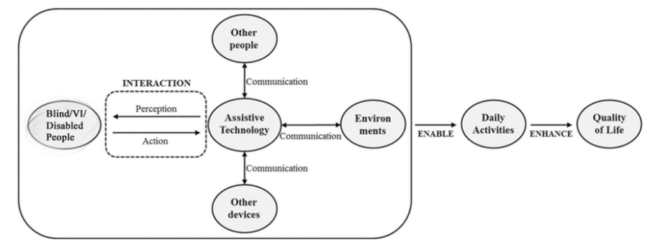

**Source:** https://www.researchgate.net/profile/Akif-Khan-7/publication/342171252/figure/fig1/AS:960353970180109@1605977637593/Diagram-of-assistive-technology-working-model-for-people-with-visual-impairment-and.png

**Who can benefit from assistive Technologies?**

It is true that assistive technologies have lots of benefits for people with disabilities. With the help of the latest assistive technologies people with disabilities can live a better life and can work like other employees in the corporations. Overall it can be said that assistive technologies have benefits for both employers and employees. Below are some of the major benefits that employees and employers can take from assistive technologies:

**Employers**

* By providing assistive technologies to people with disabilities employers can meet the health and safety requirements that are essential for corporations to meet.
* With assistive technologies not only employers can meet their legal obligations but also save huge amounts of expenses incurred on work-related injuries.
* The latest assistive technologies are quite advanced which means that they consume less energy and provide better results than previous technologies. It means that the latest assistive technologies save lots of expenses as well (Abdul & Li, 2020).
* Employers of corporations can boost their productivity and efficiency which helps them to increase the profitability of the business.
* By providing a safer workplace environment employers can increase their reputation in the market which will ultimately help the corporation to become a major brand.

**Employees**

* Employees who have some sort of physical disability can improve their performance with the help of assistive technologies. The technologies which include communication devices, literacy equipment, and hearing aids can boost performance up to a lot of extents.
* By providing Braille keypads and wheelchair ramps at the workplace the employees who are suffering from disabilities can move easily in the organization
* Employees who are suffering from various diseases and mental health conditions can also benefit from assistive technologies (Hook, 2019).
* When they are going to get support and opportunities at the workplace then their performance will enhance which is beneficial for both employees and employers.

**Benefits of Assistive Technologies**

Assistive technologies have various benefits for employees who are suffering from some kind of disability. With the help of assistive technologies not only people with disabilities can better perform in the workplace but also can improve their performance to a lot of extent. Some of the major benefits are discussed in detail below:

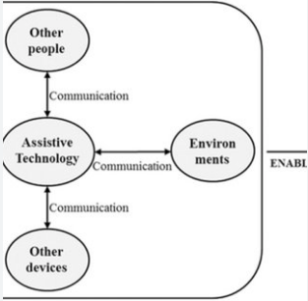

**Source:** https://www.researchgate.net/profile/Akif-Khan-7/publication/342171252/figure/fig1/AS:960353970180109@1605977637593/Diagram-of-assistive-technology-working-model-for-people-with-visual-impairment-and_Q320.jpg

**Effective Communication**

In various major organizations, there are many employees who are suffering from deafness or hard of hearing. For such employees, assistive technologies play a vital role and help them to communicate effectively with other employees in the organization. With assistive technologies, the employees who are suffering from hearing and speaking disabilities can communicate more accurately with members which will definitely boost operational efficiency in the organization. Through assistive technology, the chances of errors at the workplace due to miscommunication will also decline to a greater extent. Overall it can be said that for better communication in the workplace assistive technologies have gained immense importance (Liffick, 2003).

**Increase in Productivity & Efficiency**

It is true that assistive technologies can improve the efficiency and productivity of employees who suffer from some sort of disability. For instance, employees who are suffering from cognitive, learning, and other physical or mental health disorders can perform better at the workplace with the help of assistive technologies. Today there are many pieces of equipment, gadgets, and software that are specially designed for people with disabilities. When such employees' performance is enhanced then the overall performance of the business will improve which will help the business to become successful in the market (Rocha, et al., 2019).

**Increase in Motivation and Job satisfaction**

When people with disability are going to know that the corporation is focusing on assistive technologies and providing disabled employees various opportunities at the workplace then the motivation of such employees will increase which will further increase the performance and efficiency of the employees. Motivation and job satisfaction are highly important for any corporation because if the employees are not going to be motivated then their performance will decline which will going to have a negative impact on sales generation and the profitability of the business. Low motivation and job satisfaction can lead to an increase in the turnover rate of employees which is not good for the overall growth of the business.

**Improvement in the mental and physical health of employees**

When people with disabilities who work in different corporations are not going to get access to assistive technologies then their mental stress can increase to a lot of extent. With high amounts of physical and mental stress, such employees cannot work effectively in the corporation. In the end, such employees will leave the corporation and the corporation will lose its talented employees. In order to improve the performance of employees and retain talent at the workplace it is important to provide assistive technologies to employees who are suffering from disabilities. Through assistive technologies, employees can control their mental and physical stress effectively (Simons, 2011).

**Cultural Diversity and Inclusion**

If the organization is in the position to provide assistive technologies to people with disabilities then the organization will have the opportunity to recruit employees from various parts of the world. With assistive technologies, the organization can increase its cultural diversity and include employees who are talented but suffering from some sort of disability. With assistive technologies various talented employees will get the opportunity to use their skills and abilities for the growth and success of the organization. Gaining a competitive edge over the competitor's cultural diversity in the workplace is essential.

**Increase in Independence/Confidence**

Through assistive technologies people with disabilities can boost their confidence and can become independent in the workplace. With assistive technologies people with disabilities no longer need to rely on other individuals for help. The latest assistive technologies are quite advanced and allow people with disabilities to gain full independence. When their reliance on other individuals decreases their confidence increases which helps them to improve their performance at the workplace. With higher confidence their motivation and overall job satisfaction also increase. In short with higher confidence people with disability can handle various situations without any problems (Sahoo, et al., 2016).

**Conclusion**

It is concluded that with a high amount of physical and mental stress, such employees cannot work effectively in the corporation. In the end, such employees will leave the corporation and the corporation will lose its talented employees. In order to improve the performance of employees and retain talent at the workplace it is important to provide assistive technologies to employees who are suffering from disabilities. It is true that assistive technologies can improve the efficiency and productivity of employees who suffer from some sort of disability. Employees who are suffering from cognitive, learning, and other physical or mental health disorders can perform better at the workplace with the help of assistive technologies.

**References**

Abascal, J., 2002. Human-computer interaction in assistive technology: from Patchwork to Universal Design. Volume 3, pp. 1-6.

Abdul, C. & Li, Y., 2020. THE IMPACT OF TECHNOLOGY ON RECRUITMENT PROCESS. *Issues in Information Systems,* 21(4), pp. 9-17.

Hook, C., 2019. *Introducing Human Resource Management.* s.l.:Pearson UK.

Liffick, B. W., 2003. Assistive technology as an HCI topic. *Journal of Computing Sciences in Colleges,* 19(2), pp. 142-144.

Rocha, Á., Ferrás, C. & Paredes, M. eds., 2019. *Information Technology and Systems: Proceedings of ICITS.* s.l.:Springer.

Sahoo, P. K., Mohapatra, S. K. & Wu, S.-L., 2016. Analyzing Healthcare Big Data With Prediction for Future Health Condition. Volume 4, pp. 9786 - 9799.

Simons, R., ed., 2011. *Human Resource Management: Issues, Challenges, and Opportunities.* s.l.:CRC Press.